Carl Rakosi (1903-2004)

Carl Rakosi was an innovative American poet associated with the Objectivist movement in American poetry. His career spanned much of the twentieth-century and extended into the twenty-first, and his poetry has been noted for its moral seriousness, humor, irony, and wit. As a young poet publishing in the various little magazines of the modernist period, Rakosi came to the attention of Louis Zukofsky, who would initiate his life-long involvement with the Objectivists.

Born in Berlin, Rakosi moved to Hungary with his mother after his parents separated in 1904, but was sent at the age of six to Chicago to live with his father. In 1920, he attended the University of Chicago and began to write poetry; the following year he transferred to the University of Wisconsin, editing the *Wisconsin Literary Magazine*. Rakosi’s political commitments led him to the Communist Party during the 1930s, and his search for gainful employment led him to social work (in response to anti-Semitism, he adopted the professional name Callman Rawley). Around 1939, Rakosi fell silent as a poet, and he did not resume writing poetry until he neared retirement in 1968. Living until the age of 100, he enjoyed a long and productive late career as a poet.

Rakosi’s association with the Objectivists began when Zukofsky included his work in the Objectivist number of Harriet Monroe’s *Poetry* magazine in 1931, and in the book-length collection, *An ‘Objectivists’ Anthology* (1932). Despite feeling that the Objectivist movement lacked coherence, Rakosi acknowledged that the term Objectivist did seem to him “useful”: “It conveyed a meaning which was, in fact, my objective: to present objects in their most essential reality and to make of each poem an object” (“A Note” 36). Rakosi also came to know and admire the other core Objectivist poets, Charles Reznikoff and George Oppen. His poem on Oppen’s descent into Alzheimer’s, “The Old Poet’s Tale,” is a powerful longer sequence, and something of an exception in a body of work comprised mostly of shorter lyric poems. The view of Rakosi as a poet devoted primarily to the lyric can be revised, however, if we consider him--like Zukofsky, Oppen, and Reznikoff--a practitioner of serial form. We can see Rakosi working in such a mode in his incomplete early sequence “The Beasts” (*Poems 1921-31*), and in his structuring of the *Collected Poems* (1986), which presented a new arrangement of all his work. It should also be noted that Rakosi, who started out with “very little sense of Jewish identification” (Hatlen 107), eventually devoted many poems to Jewish themes.

Steven Shoemaker

Connecticut College

*List of Works*

Rakosi, Carl. (1986) *The Collected Poems of Carl Rakosi*, Orono, ME: National Poetry Foundation.

---. (1995) *Poems 1923-1941*, Los Angeles: Sun and Moon Press. Andrew Crozier, (ed.)

---. (1969) “A note on the ‘Objectivists.’” *Stony Brook* 3 (4): 36-37.

Hatlen, Burton. (1986) “Interview with Carl Rakosi.” *Sagetrieb* 5 (2): 95-123.

Heller, Michael, (ed.) (1993) *Carl Rakosi: Man and Poet,* Orono, ME: National Poetry Foundation.

Zukofsky, Louis. (1932) An ‘Objectivists’ Anthology, France: To Publishers.

*Paratextual Materials*

Please note that the first four links appear in the Rakosi entry at Wikipedia:

Modern American Poetry site: <http://www.english.illinois.edu/maps/poets/m_r/rakosi/rakosi.htm>

Rakosi Reading and interview on KPFA: <http://archive.org/details/CarlRakosiReading>

Rakosi Feature in *Jacket* magazine: <http://jacketmagazine.com/25/index.shtml>

Add-Verse poetry/photo/video project: <http://www.add-verse.info/>

University of California, Berkeley, Bancroft Library, Regional Oral History Office, Carl Rakosi feature: <http://bancroft.berkeley.edu/ROHO/projects/arts_ca/> (This feature includes several videos of Rakosi.)

Finding aid for Carl Rakosi papers at University of California, San Diego, Mandeville Special Collections: <http://www.oac.cdlib.org/findaid/ark:/13030/tf0j49n7w4/entire_text/>

*Photos*:

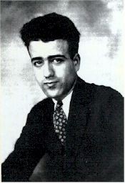

Early photo included on the Modern American Poetry site, without source information.

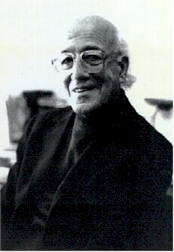

Also on Modern American Poetry Site.

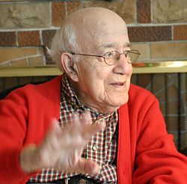

Late photo included in Wikipedia article. Identified as follows: Carl Rakosi at 100 years old, photo by [Gloria Graham](http://en.wikipedia.org/wiki/Gloria_Graham), taken during the video taping of Add-Verse, 2003.

Other photos are available online and may be found through Google Photos.